Software Piracy

A Project Report Submitted
for

Information Technology
By

Abhishek Koranga
(Roll no. 1)

Under the guidance of
Mr. Praveen Kumar Joshi



EVER GREEN SENIOR SECONDARY SCHOOL
(GOVERNED BY EDUCATIONAL WELFARE SOCIETY)
TULARAMPUR - 223139, DISTRICT-NAINITAL
UTTARAKHAND, INDIA

OCTOBER, 2021

CERTIFICATE

This is to certify that the project entitled “Software Pirarcy” being submitted to Evergeen Senior Secondary School, Haldwani for the project work of INFORMATION TECHNOLOGY is a record of the work carried by MR. PRAVEEN KUMAR JOSHI under my guidance and supervision.

Date: Supervisor
MR. PRAVEENJOSHI
TGT Computer
Ever Green Sr. Sec. School, Haldwani
Forwarded By:
MR. M.S. PARWAL
Principal
Ever Green Sr. Sec. School, Haldwani

ABSTRACT

Software piracy has become a worldwide issue with China, the United States, and India being the top three offenders. The commercial value of pirated software is $19 billion in North America and Western Europe and has reached $27.3 billion in the rest of the world. According to the 2018 Global Software Survey, 37% of software installed on personal computers is unlicensed software.
Software piracy doesn’t require a hacker or skilled coder. Any normal person with a computer can become a software pirate if they don’t know about the software laws. With such a widespread impact, it’s important to understand what software piracy is and the dangers it presents.

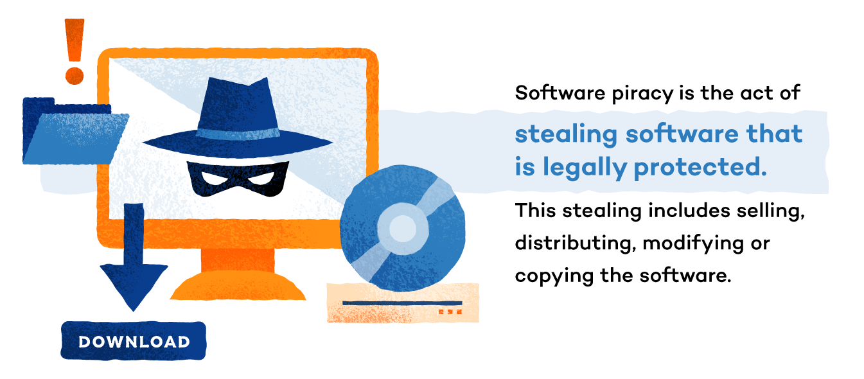

Software Piracy – Definition
Software piracy is the act of stealing software that is legal

ly protected. This stealing includes copying, distributing, modifying or selling the software.
Copyright laws were originally put into place so that the people who develop software (programmers, writers, graphic artists, etc.) would get the proper credit and compensation for their work. When software piracy occurs, compensation is stolen from these copyright holders.

Software Piracy Regulation
Computer piracy is illegal and constitutes a federal crime. The monetary penalties for those who break this law can reach up to $150,000 per instance of copyright violation.

End-User License Agreement
The End-User License Agreement (EULA) is a license used for most software. It is a contract between the manufacturer and/or author and the end user. This agreement defines rules for software use and not every 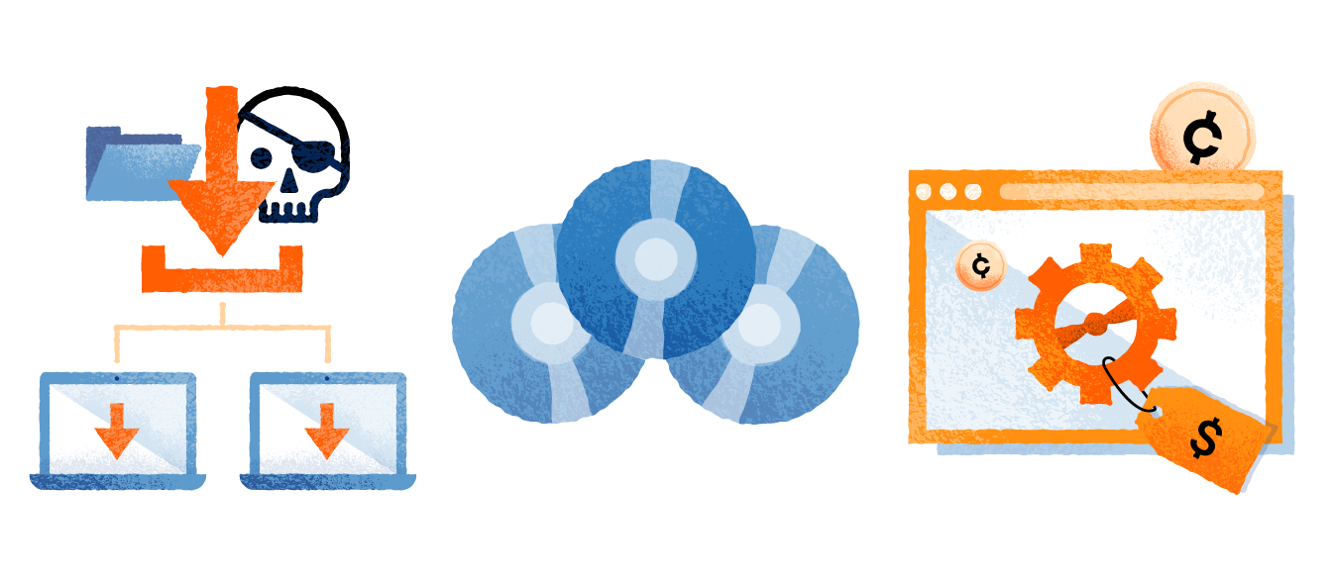agreement is the same. One common rule in most EULAs prohibits users from sharing the software with others.

Types of Software Piracy
There are five main types of software piracy. This variety of pirating techniques explains how some individuals purposely pirate software while others may unknowingly be an accomplice.

Softlifting
Softlifting is when someone purchases one version of the software and downloads it onto multiple computers, even though the software license states it should only be downloaded once. This often occurs in business or school environments and is usually done to save money. Softlifting is the most common type of software piracy.

Client-server overuse
Client-server overuse is when too many people on a network use one main copy of the program at the same time. This often happens when businesses are on a local area network and download the software for all employees to use. This becomes a type of software piracy if the license doesn’t entitle you to use it multiple times.

Hard disk loading
software piracy in which someone buys a legal version Hard disk loading is a type of commercial of the software and then reproduces, copies or installs it onto computer hard disks. The person then sells the product. This often happens at PC resale shops and buyers aren’t always aware that the additional software they are buying is illegal.

Counterfeiting
Counterfeiting occurs when software programs are illegally duplicated and sold with the appearance of authenticity. Counterfeit software is usually sold at a discounted price in comparison to the legitimate software.

Online Piracy
Online piracy, also known as Internet piracy, is when illegal software is sold, shared or acquired by means of the Internet. This is usually done through a peer-to-peer (P2P) file-sharing system, which is usually found in the form of online auction sites and blogs.

The Dangers of Software Piracy
Software piracy may have a cheaper price point, but there are many dangers that software pirates should be aware of.
Consequences of software piracy are:
- Increased chances that the software will malfunction or fail
- Forfeited access to support for the program such as training, upgrades, customer support and bug fixes
- No warranty and the software can’t be updated
- Increased risk of infecting your PC with malware, viruses or adware
- Slowed down PC
- Legal repercussions due to copyright infringemt

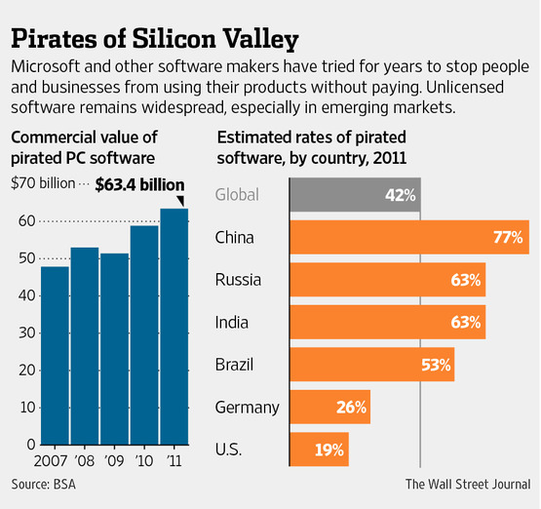

ACKNOWLEDGEMENTS
I would like to that my teacher (MR.Praveen Joshi) who gave me this opportunity to work on this project. I got to learn a lot from this project about (Software Pirarcy). I would also ike to thank our school principal (Mr.M.S.Parwal).
At last I would like to extend my heartfelt thanks to my friend without their help this projec would not have been successful. Finally, I would to thank my elder brother who have been with me all the time .

(ABHISHEK KORANGA)

TABLE OF CONTENTS

Chapter | Topic | Page No.
 | CERTIFICATE | 2
 | ACKNOWLEDGEMENT | 7
 | LIST OF FIGURES | 3
 | ABSTRACT | 3
1. | INTRODUCTION | 3
1.1 | SUMMARY AND FUTUREWORK | 8

